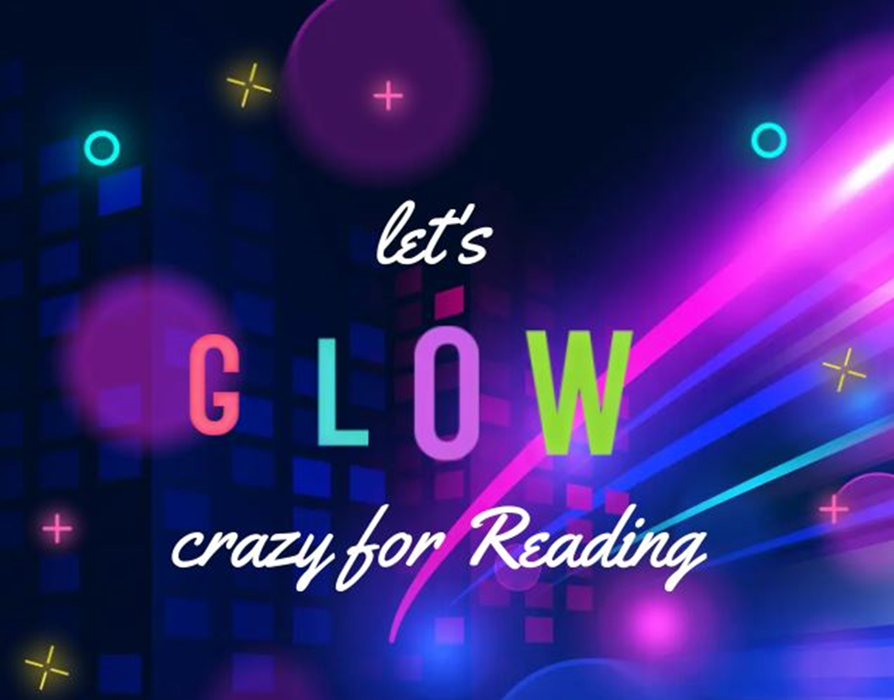
Please join us for
FAMILY Literacy Night
When: Tuesday, May 2nd
Where: Family Life Center
Who: All Preschool – 8th graders
Time: 6 – 7:15 PM
What: “Let’s GLOW Crazy for Reading” Literacy Night
- GLOW activities around the school
- Book Swap
  - Please bring a book(s) that your child has outgrown or moved on from so you can swap it out at our Book Swap for a "new" book to take home.
- Read to a comfort dog
- Goodie bags
Please send this REGISTRATION FORM to a classroom teacher by Friday, April 21st so we can prepare for the fun!
________________________________________________
____ YES, Our family plans to attend! There will be ____ children.
Names and grades of children: Name _______________ Grade ____
Name _______________ Grade ____
Name _______________ Grade ____
Name _______________ Grade ____
Family Name _____________________________________________

